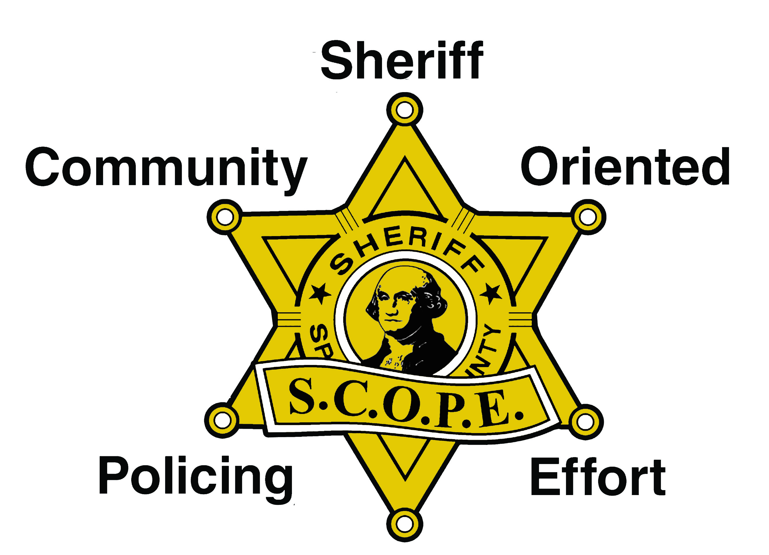
S.C.O.P.E. Main
12710 E. Sprague Ave.
Spokane Valley, WA 99216
Rick Scott, Director
(509) 477-3376

S.C.O.P.E. Donation Form

DONOR: Individual or Business Name:
Address:
City, State, Zip:
Phone: |  | Fax:
Item Donated or Amount (if cash):
Donation Intent:
(describe if for an event or specific program)
Date of Donation:

S.C.O.P.E. Station:
Volunteer’s Name:
Station Phone: |  | Fax:

S.C.O.P.E. Federal Tax ID#: 91-1645413
S.C.O.P.E. is a 501(c)(3) non-profit corporation and your donation is tax-deductible as allowed by law. No goods or services were provided, in whole or in part, for this contribution.

Office Use Only: Stations, a copy of this form must be sent to SCOPE Main. In addition, please be sure to give donor a copy of this form as a receipt for their donation; however, an official thank you letter must still be sent to the donor for tax purposes.

Revised January 2014, sar

