
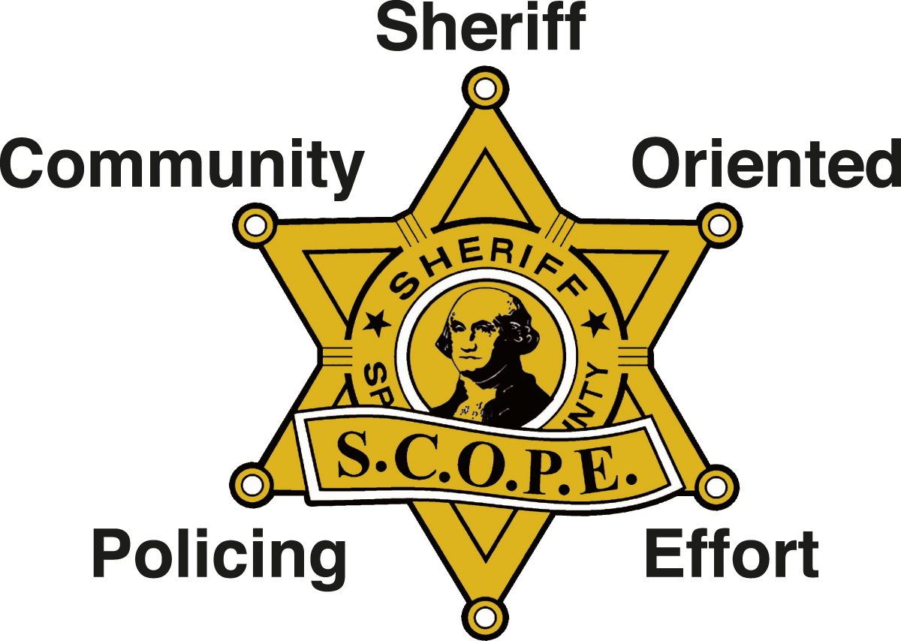

S.C.O.P.E. and the
Spokane County Sheriff’s Office

Volunteer Conduct & Confidentiality Policy and Agreement

I, ____________________________________(PLEASE PRINT NAME), connected with

____________________________________ (PLEASE PRINT NAME of SCOPE STATION), understand that appropriate conduct and maintaining confidentiality of all information is a condition of being a volunteer with S.C.O.P.E.

I acknowledge that as a S.C.O.P.E. Volunteer, I will be supporting the Spokane County Sheriff’s Office. I will not represent myself as a law enforcement officer and I will not at any time act, speak or give the appearance of being a vigilante. While representing S.C.O.P.E. and the Sheriff’s Office, I will act as extra eyes and ears for law enforcement and will have concern for our neighborhoods and our communities. I will uphold a positive image of S.C.O.P.E. and the Sheriff’s Office, and will take full responsibility for all my actions.

In connection with my work as a S.C.O.P.E. Volunteer supporting the Sheriff’s Office, I may from time to time have access to sensitive information and materials, either in written or oral form. This may include intelligence, criminal history records or investigative information. I understand that all conversations and information handled and/or heard by me as a S.C.O.P.E. Volunteer are to be considered as privileged information, and at no time will I release said information, in written or oral form.

I understand that any release of confidential information could cause harm to persons or property, and could reflect unfavorably on the Sheriff’s Office and/or the S.C.O.P.E. program. I also understand that improper disclosure of any such information could be a violation of the law, as well as the Sheriff’s Office’s Policies and Procedures. I could be subject to dismissal, in addition to any civil or criminal penalties provided for by law.

In the event that I am in discussion with and/or on scene with law enforcement personnel, I will listen and follow their instructions and heed their advice. I will remember that it is their scene and incident, and I am a volunteer supporting them.

p. 1 of 2
As a S.C.O.P.E. volunteer, I will abide by all rules and decisions handed down by the Spokane County Sheriff’s Office and S.C.O.P.E. In addition, I will strive to work harmoniously with, and be respectful of, my fellow volunteers, and will always conduct myself in a professional, friendly and moral manner. I also agree to conduct my private life in such a way that my character is beyond reproach and I am a credit to the S.C.O.P.E. program.

While representing S.C.O.P.E., I also understand that firearms are not allowed to be carried regardless of any permits or training.

If any one of the “Rules of Conduct and Confidentiality” is violated, I may be immediately removed from the S.C.O.P.E. program in its entirety, pending an appeal to the S.C.O.P.E. Board of Directors.

I also understand that my membership with S.C.O.P.E. may be terminated by the Spokane County Sheriff’s Office at any time, for whatever reason.

Dated this ________ day of ____________________, 2021

____________________________________
(Printed Volunteer Name)

____________________________________
(Volunteer Signature)

_______________________________________________________________
Signature Rick Scott, S.C.O.P.E. Director

Revised 01-12-2016, saw p. 2 of 2

